The Farmland Museum and Denny Abbey
Visual Story
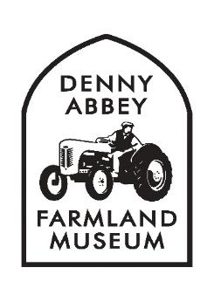

When you get to the museum:
There are accessible spaces at the front of the carpark.
To enter the museum, you go through the black building. You still need to do this even if you have a season ticket or are an English Heritage Member.
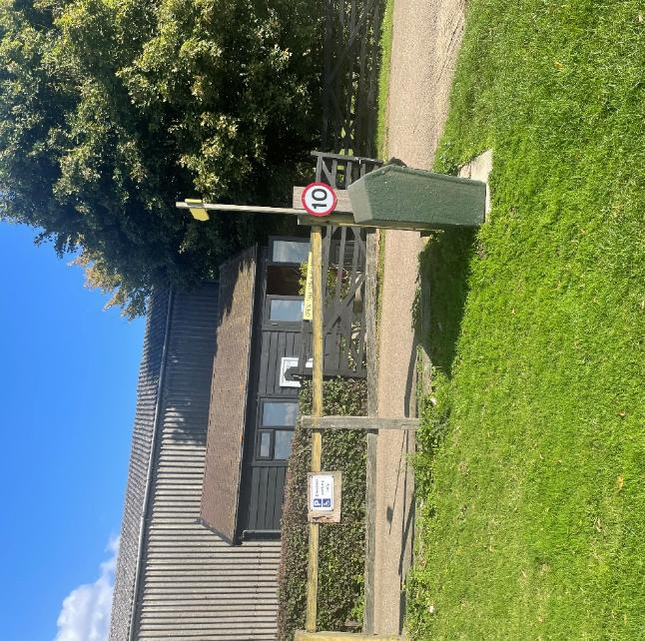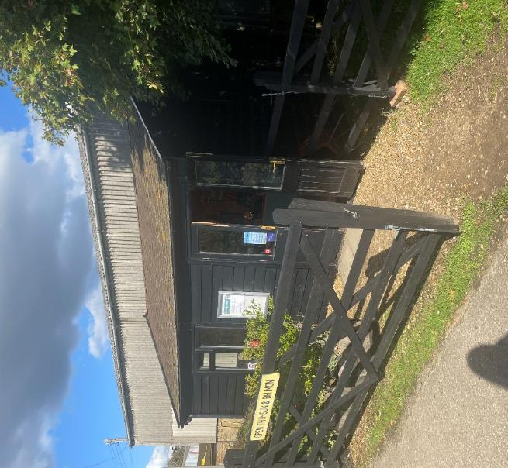
When you come in:
There will be someone to greet you. They will check your ticket or ask you to pay for one if you don’t already have one.
This is also where the gift shop is if you would like to buy anything.

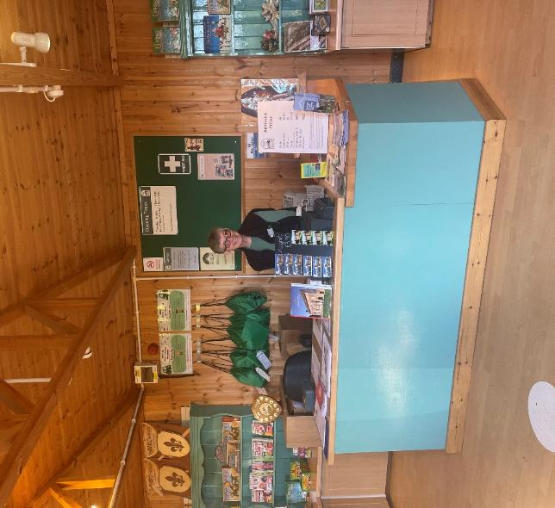
Here is a map of the museum:
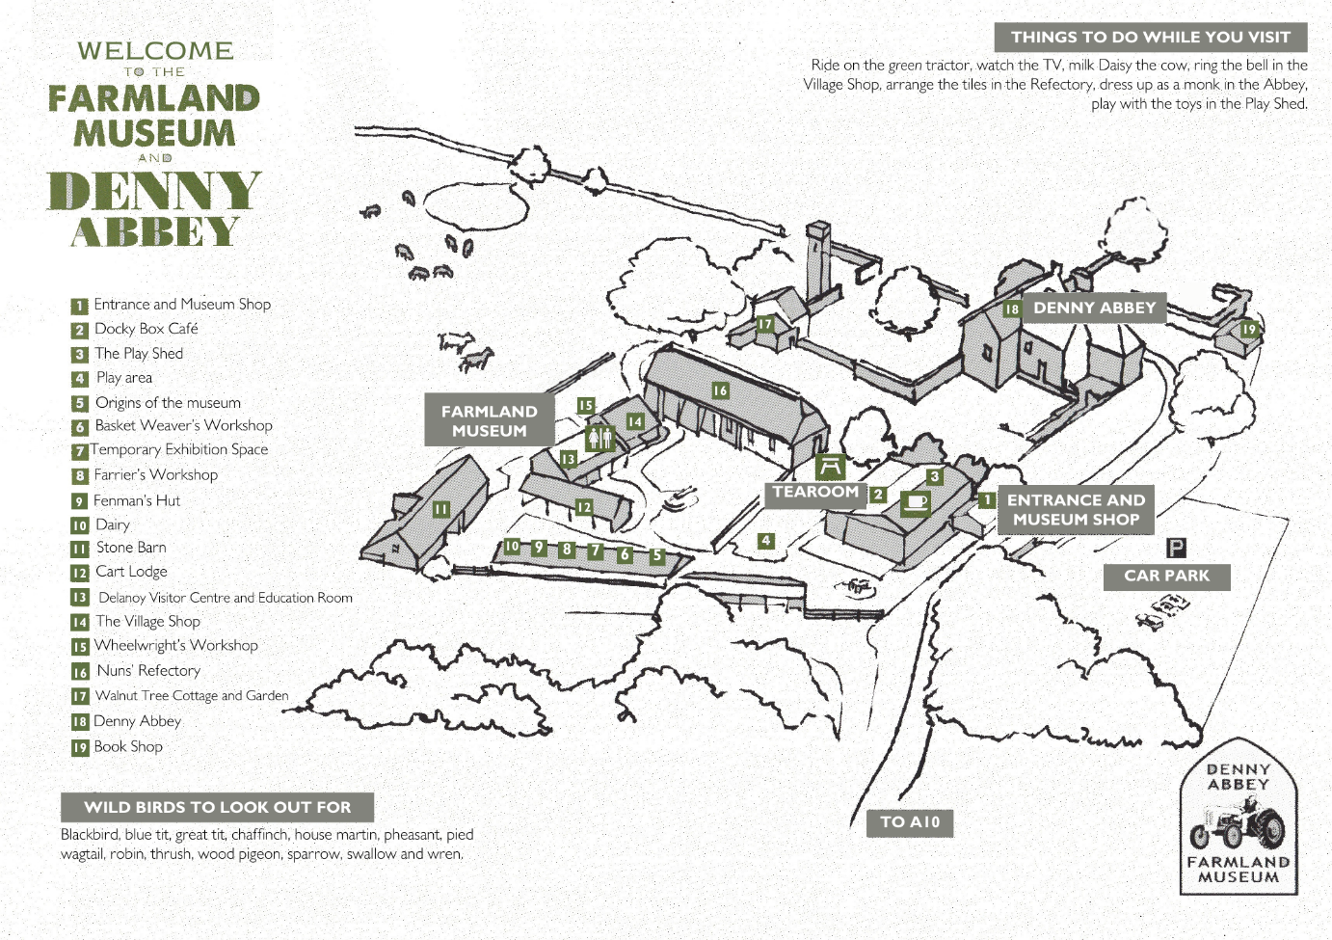
The café is here.
You came in here.
The toilets are here.
There is a real farm around the site. The farm sometimes has cows and pheasants in the fields around the museum which can be noisy.

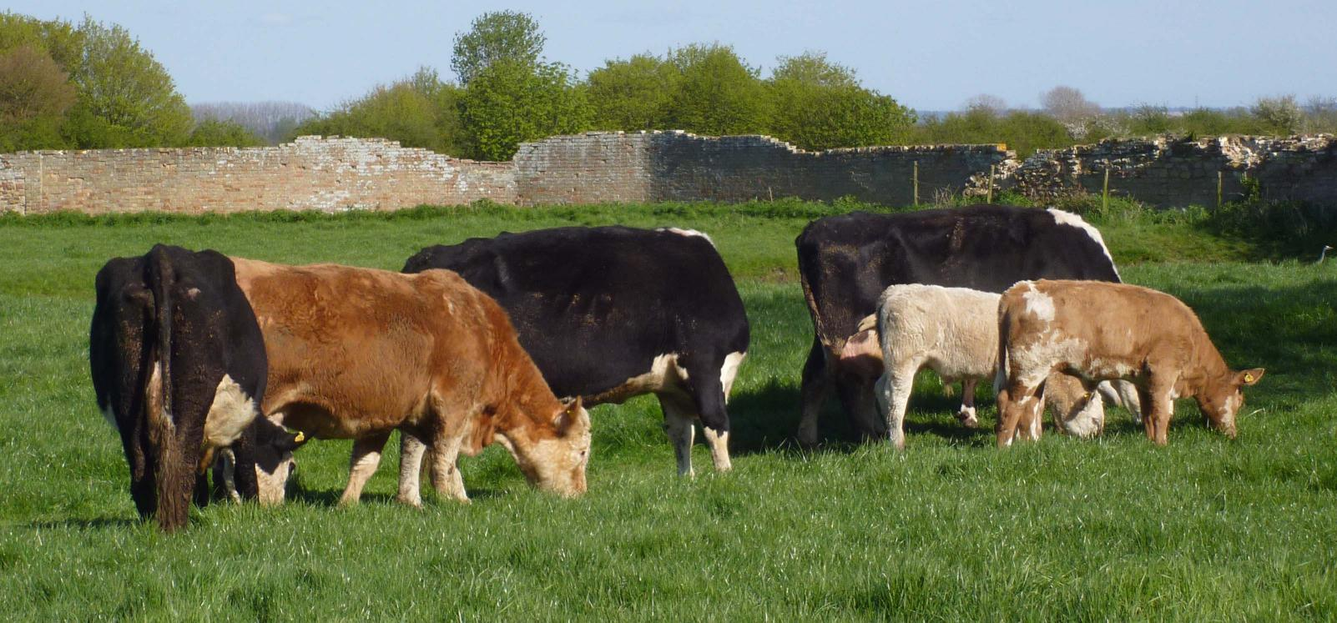

The first thing you will see:

This is a Ferguson Tractor. This tractor is on the logo of our museum. Please do not touch this tractor.

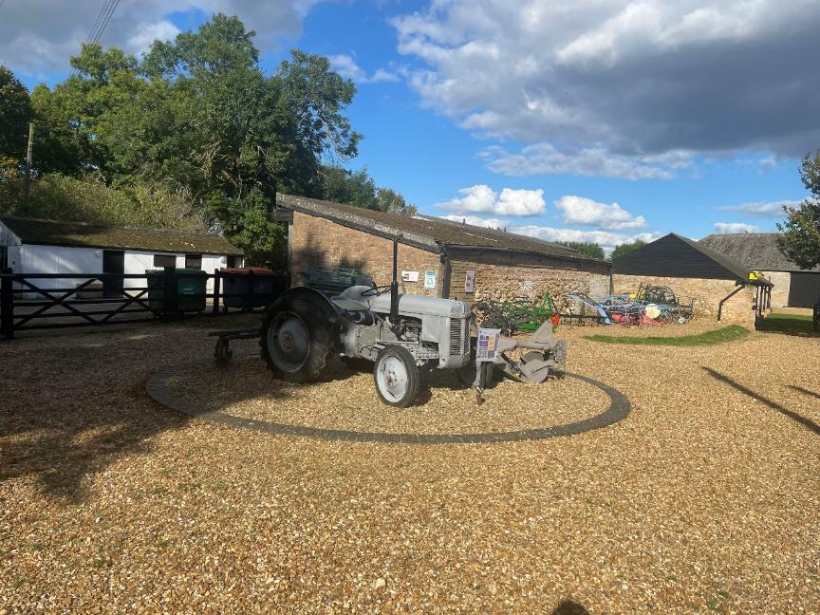
The Play Area:
The next place you will see is the play area. You can play on this equipment. There is a green tractor in the play area, you can touch and play on this tractor.
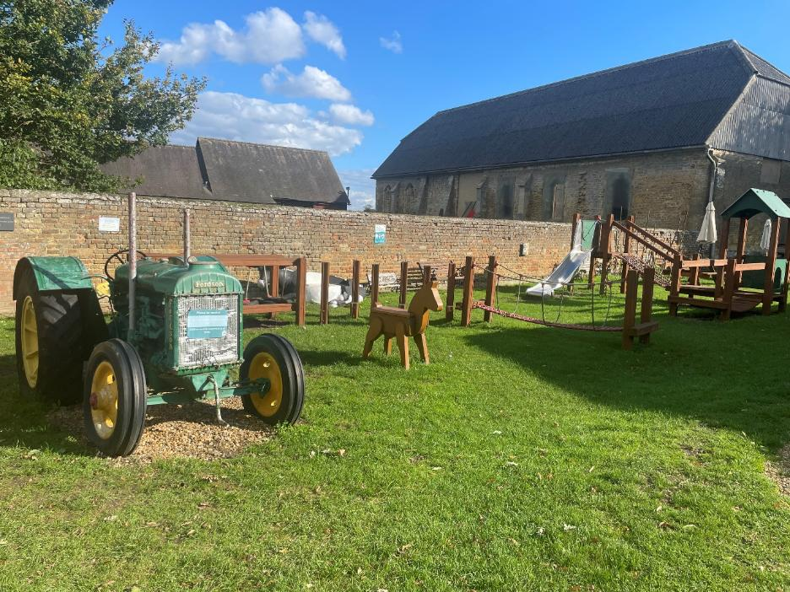
The Pig Sheds:
The first part of the museum you will see is called the ‘pig sheds.’ This is because pigs used to live in them. There are 6 pig sheds, and they all have different things in them. When you step inside sound will play.
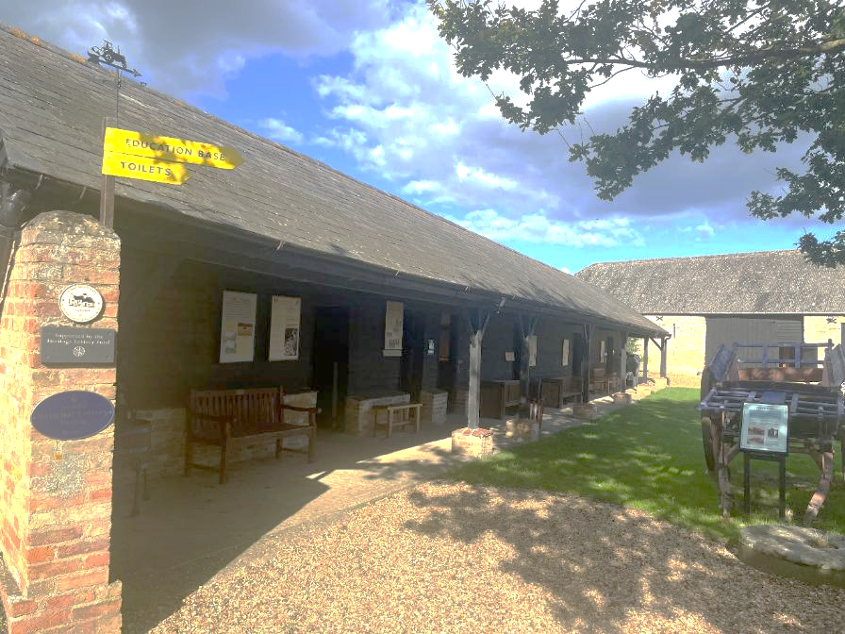
Daisy the Cow:

This is Daisy the cow. She is not a real cow. She is full of water, and you can pretend to milk her using the udders underneath.

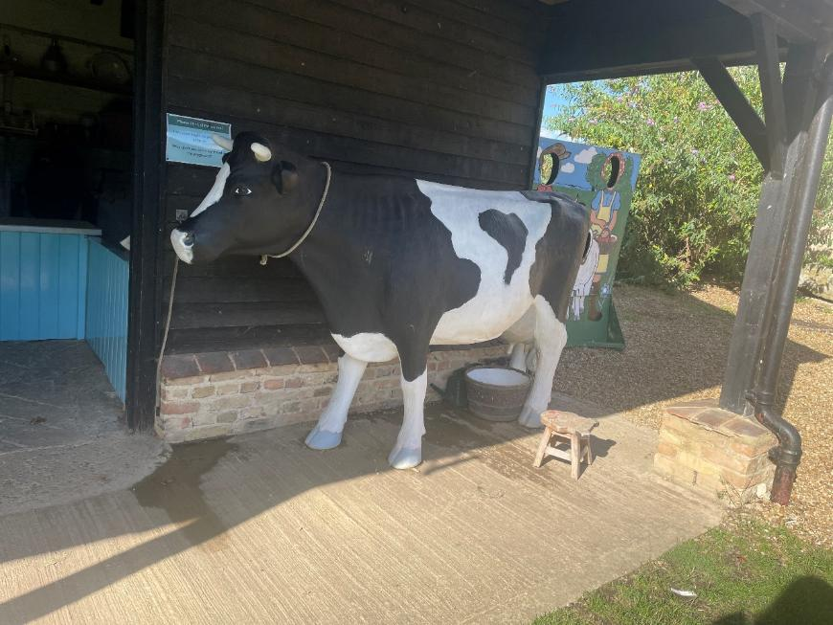
The Stone Barn:

This is a very big building. If you need help getting inside tell a member of staff and they can bring you a ramp. It is often quiet in here.

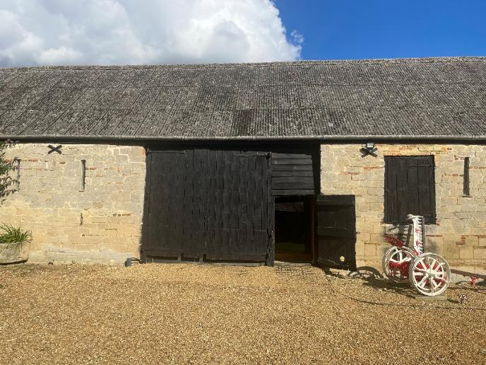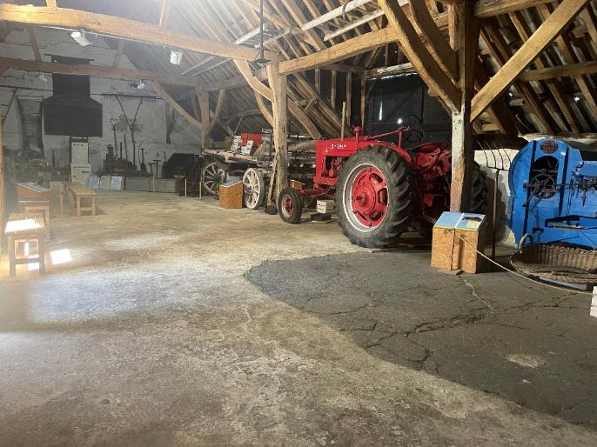
The allotment:

This is where the museum grows fruits, vegetables and herbs. You might be able to smell some of them.

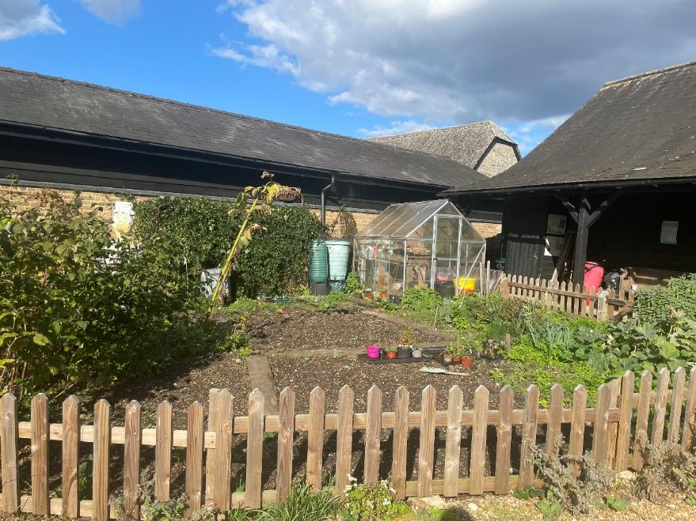
The Septic Tank:

The big green tank in the ground is the septic tank. It can be noisy. This is where the waste goes when you flush the toilet.

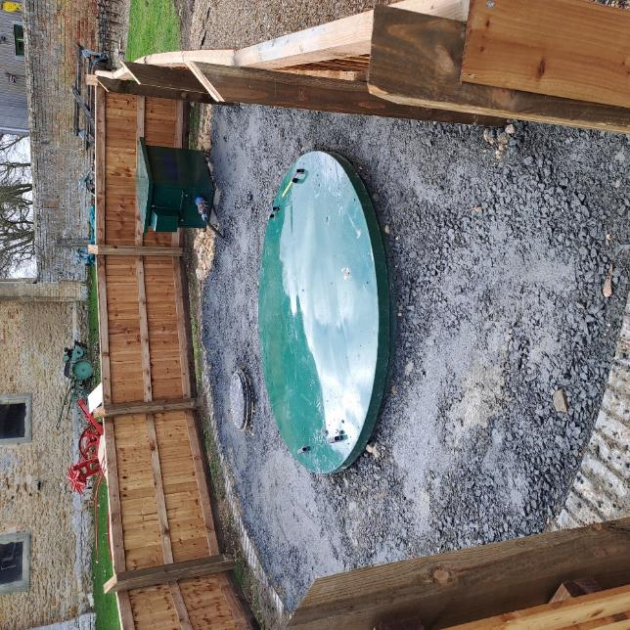
The toilets:

There are three toilets. There is one accessible toilet and two cubicles. There is paper to dry your hands.

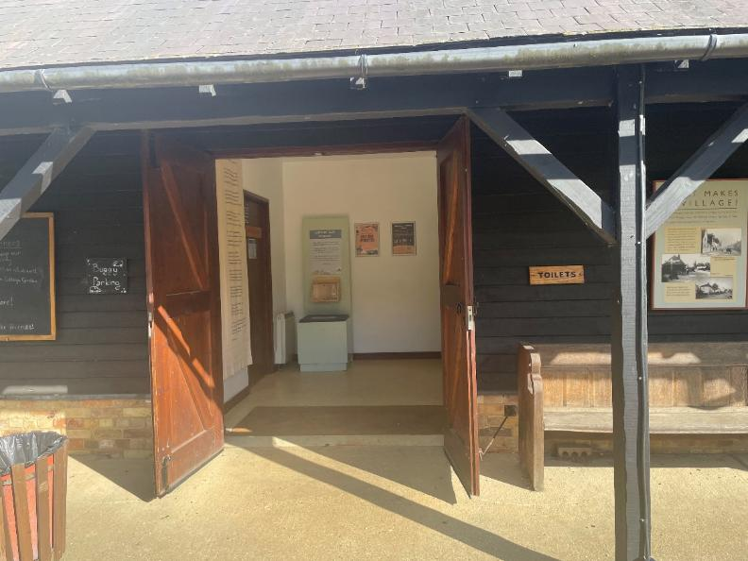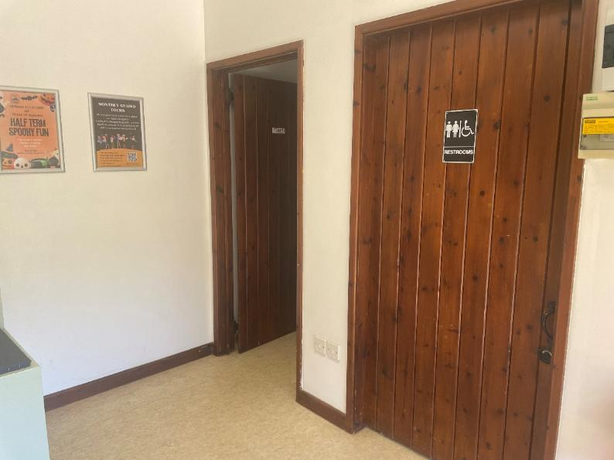
The Village Shop:

This is designed to look like an old-fashioned shop from nearly 80 years ago. There is a bell on the desk that rings if you press it. There are some buttons to press to hear a lady talking. There are weights that you can play with.

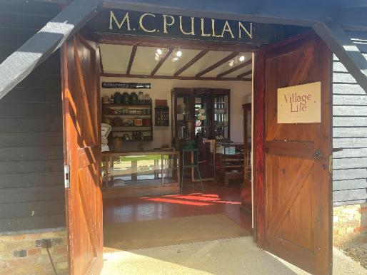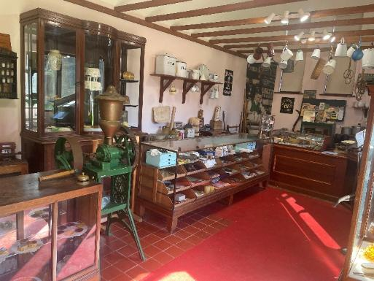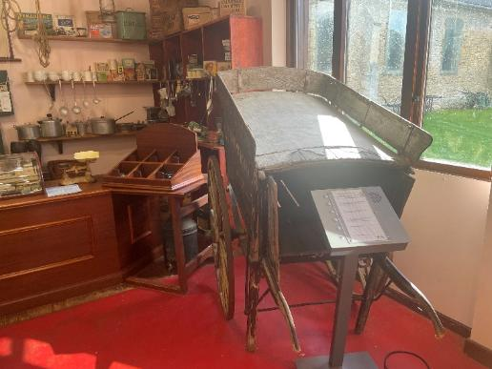

The Wheelwrights Workshop:

The Wheelwrights Workshop is behind the Village Shop. This shows you how people made wheels. There are some patterns made out of wood you can touch.

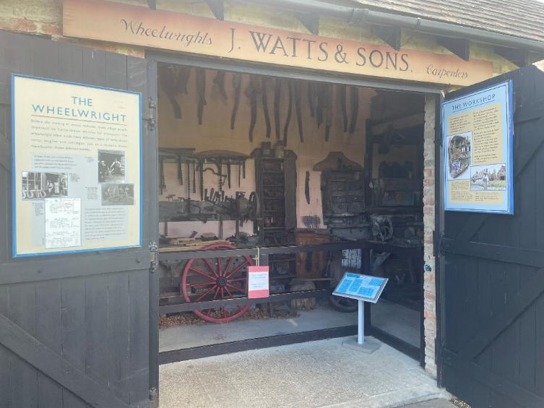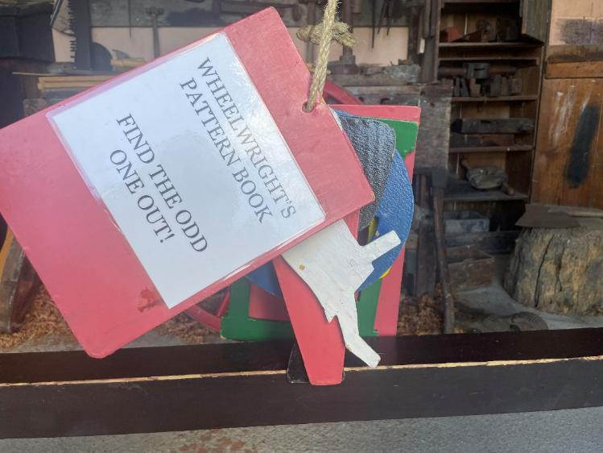
Walnut Tree Cottage:

Walnut Tree Cottage is an old farmworkers cottage. There are chairs inside you can sit on, and some things you can touch. 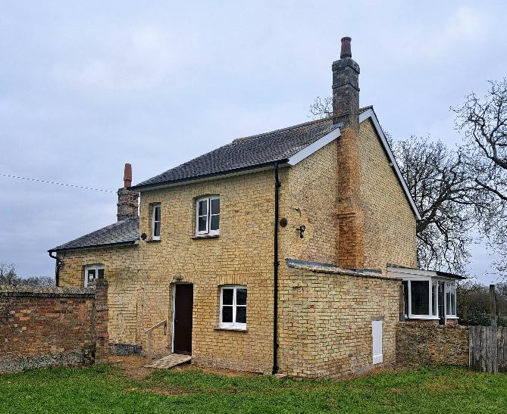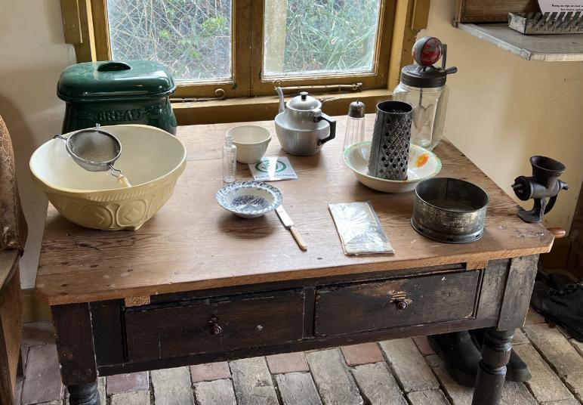

The Refectory:
There are very old tiles on the floor in here, but we are not allowed to walk on them. There is a wooden platform with a slight step to get in. There are tiles in here that you can use to make a design.
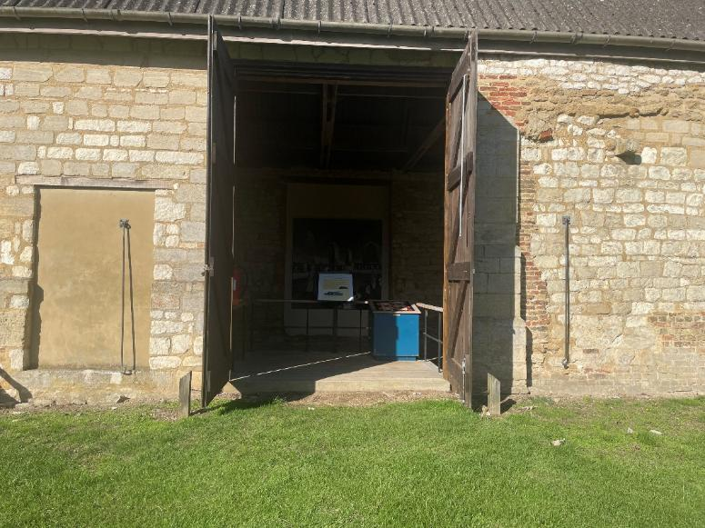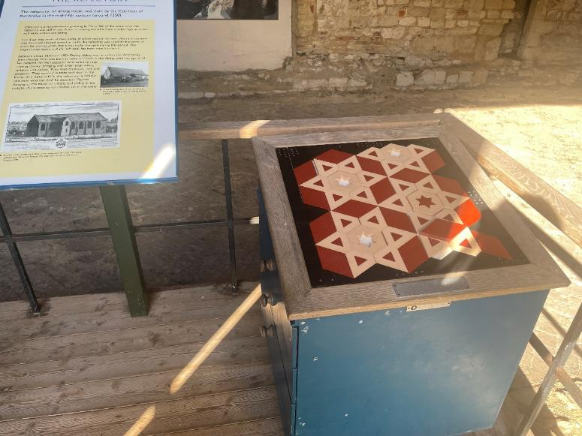

The Abbey:
This is a very big building. There are wooden walkways and earth to walk on. There are wooden stairs you can use to go upstairs. There are two models dressed up like Knights Templar. They are not real and won’t make noises.
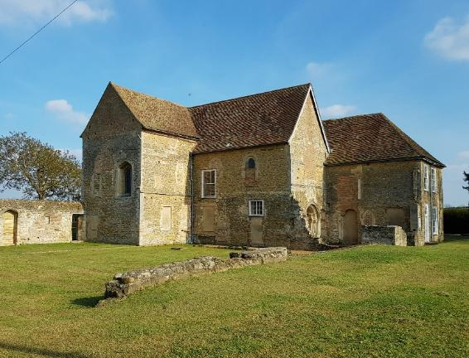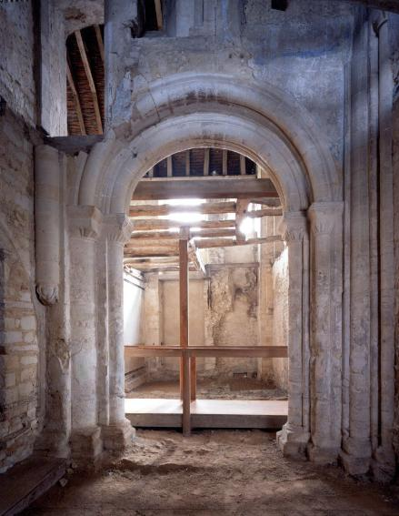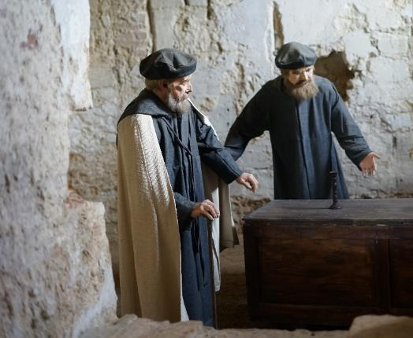

Walnut Tree Court:
There is a big walnut tree and there are some benches you can sit on. This is often a quiet place in the museum.
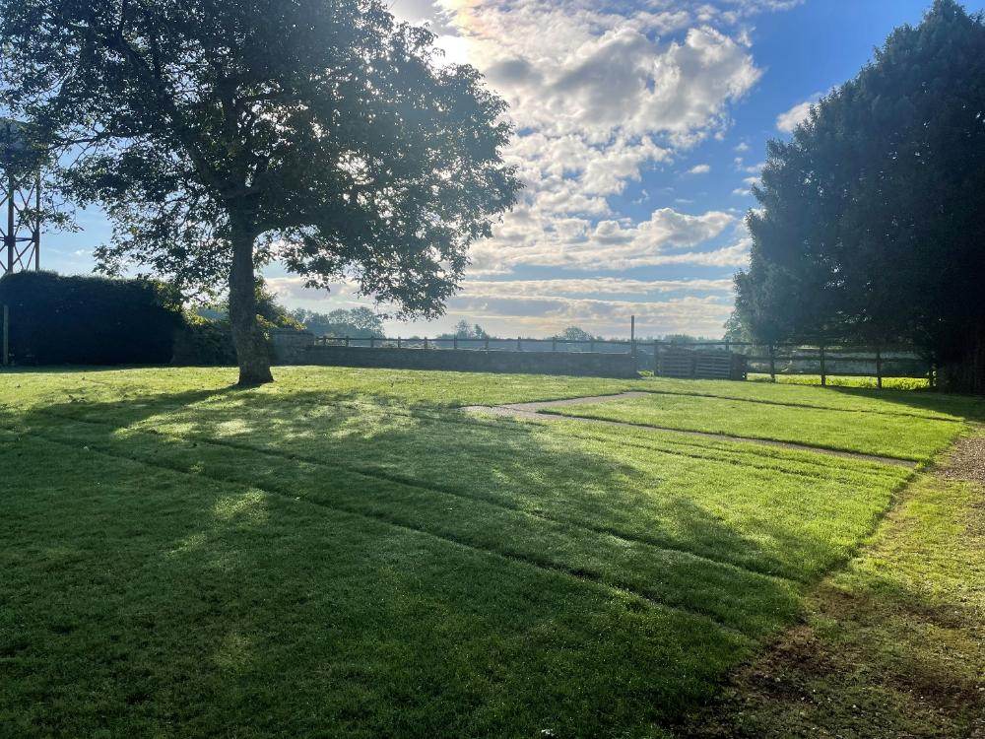
The Bookshop:
People donate books to the museum, and you can buy them from the bookshop. There is a slight step to get into the bookshop. There is a box where you can donate money, or you can pay online.
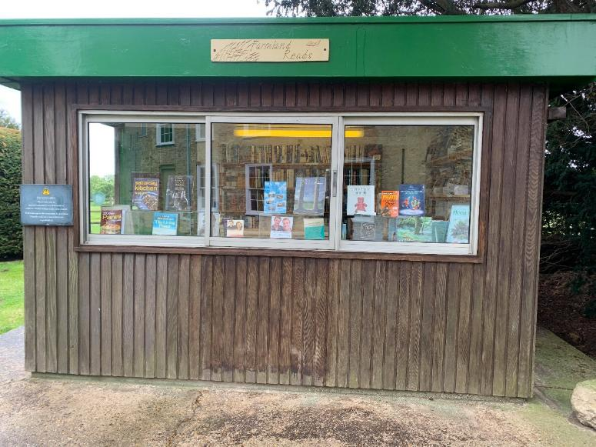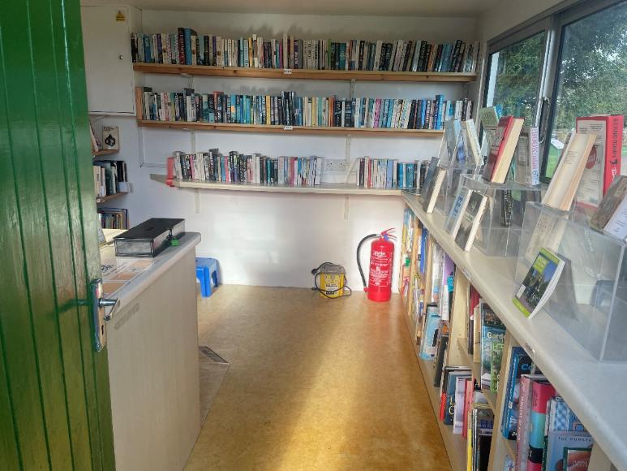

The Play Shed:
The Play Shed is full of toys that you can play with. It can get noisy in here if there are lots of children playing.

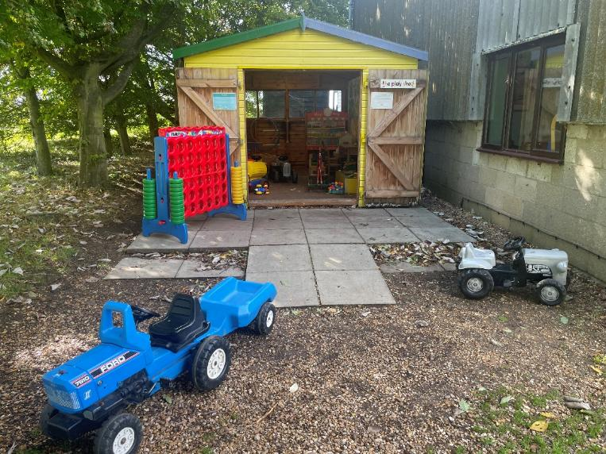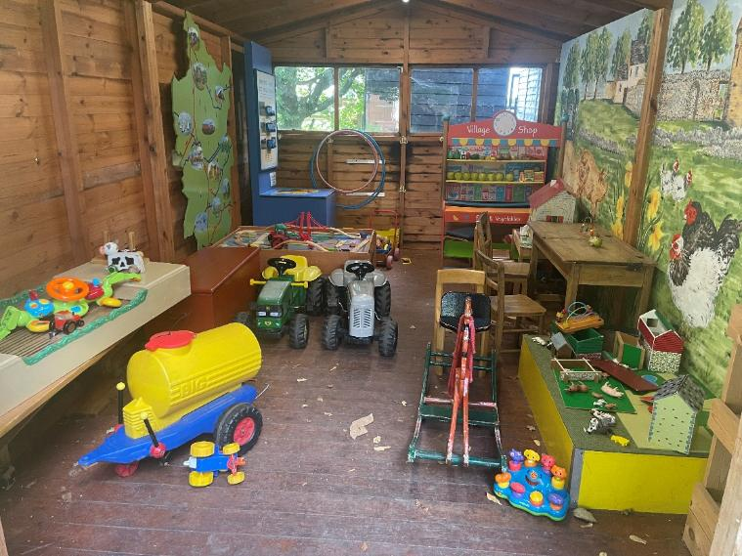

Café and Picnic Area:
The Café is inside the green doors. There are tables where you can sit inside, or there are picnic tables outside. The coffee machine in the kiosk can be loud when in use and the Café can be loud when busy.
